

MATHEMATICS
YEAR 9

Investigation 1 – Range and Measures of Centre
Semester 1 2015



Answer Sheet

Information for Students

Working time: 40 minutes
Marks available: 30 marks

Write your answers in the spaces provided.
Displaying Data
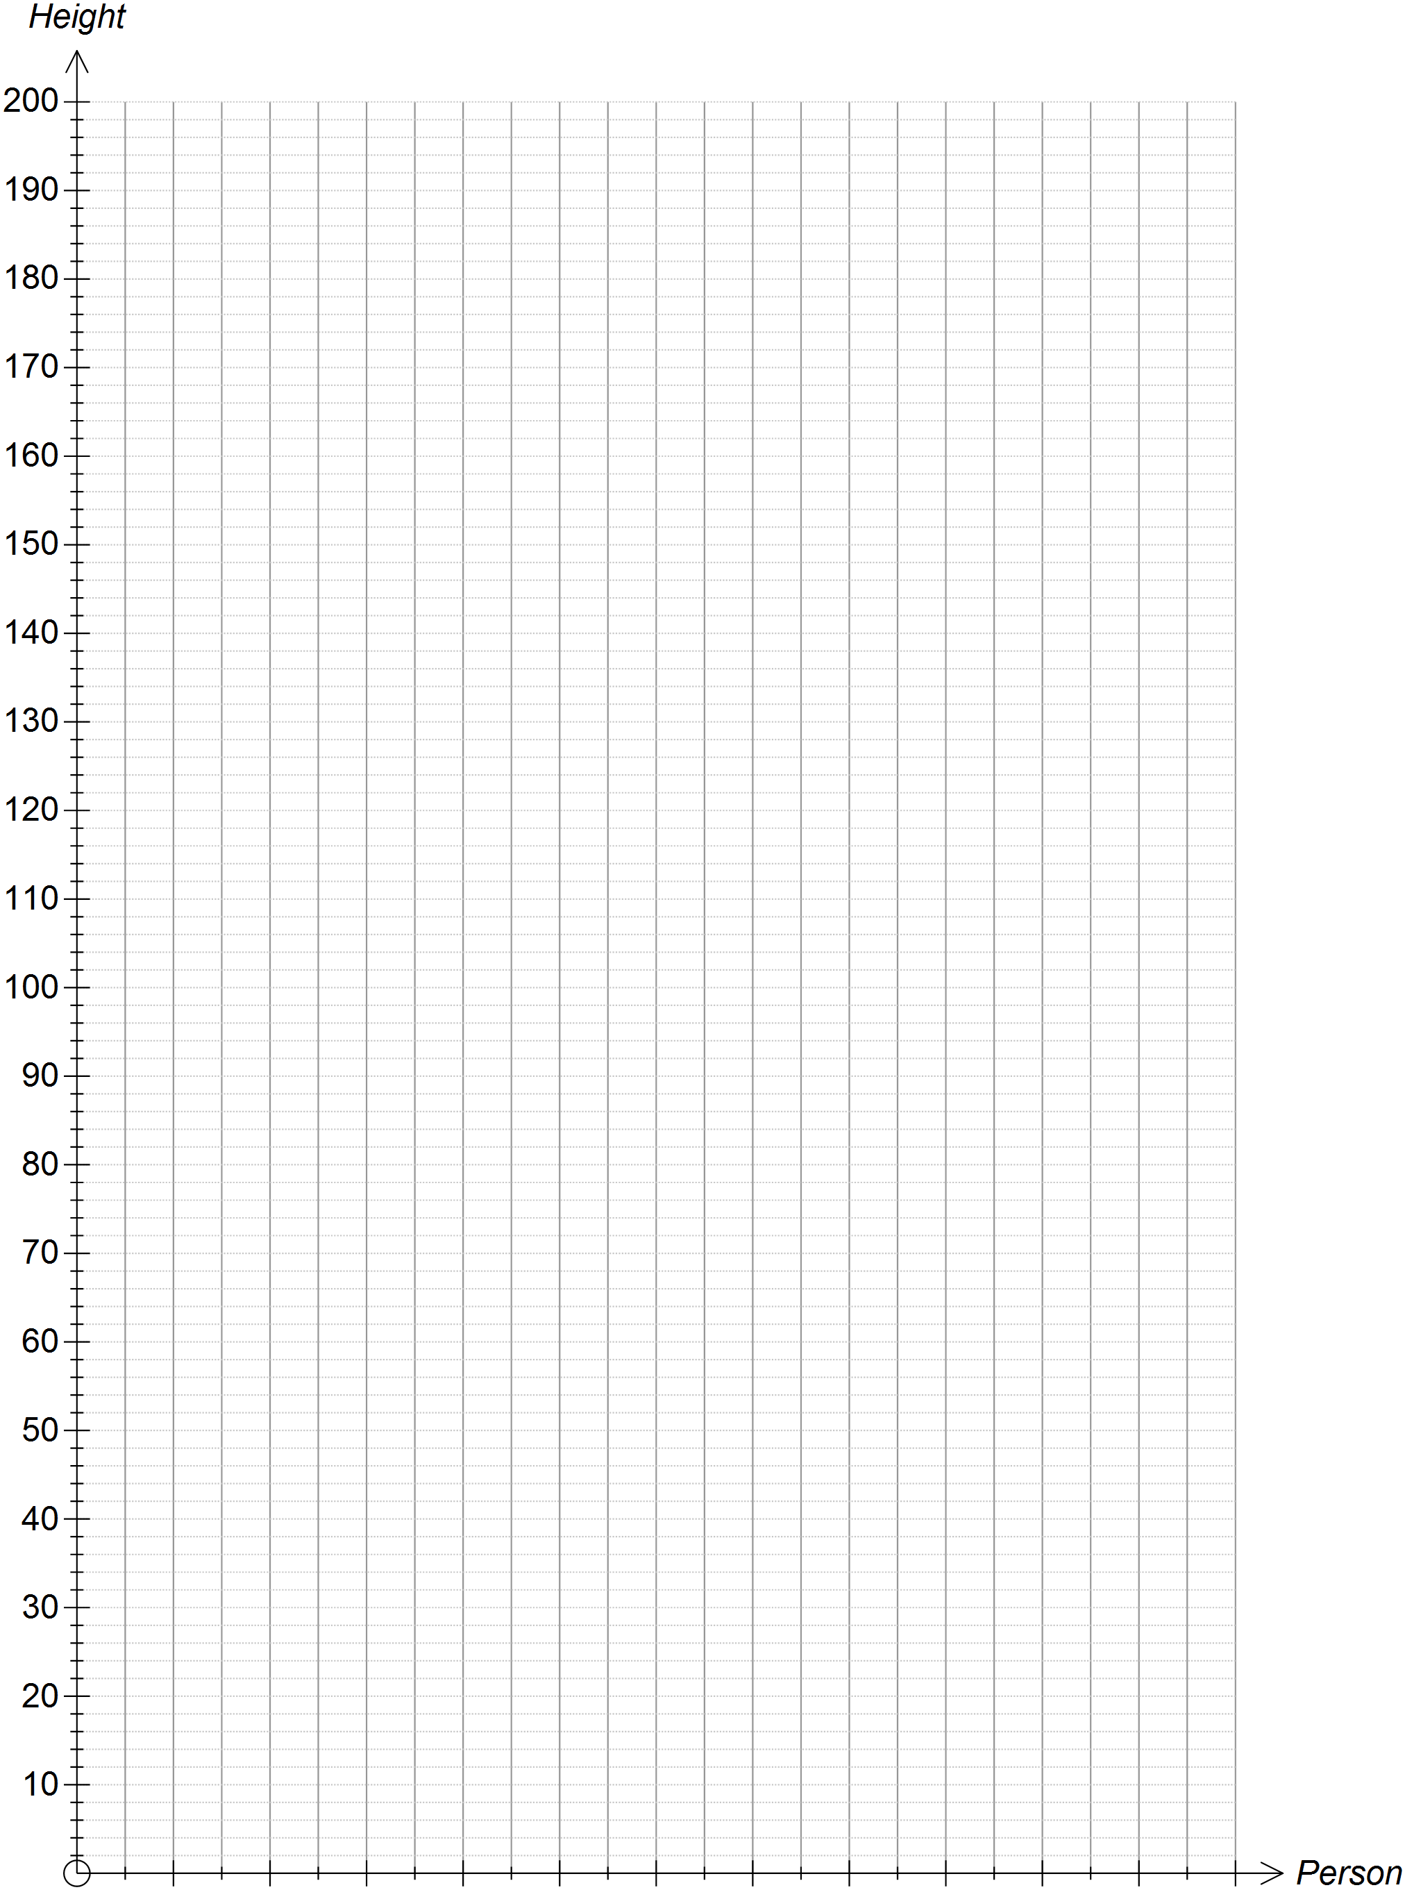

Range
- is shortest and is tallest.

Median

Mean

Mode

End of Investigation

This space is for additional working.

